The Women’s Fund invites you to join us in creating a lasting transformation in the lives of women, children, and families in our community by becoming a corporate sponsor.

OUR MISSION
Women Making a Positive Impact on the Lives of Women, Children & Families in South Central Kentucky.

A GIVING CIRCLE
Women’s Fund” is a field of interest fund of The Community Foundation of South Central Kentucky, a 501(c)3 nonprofit organization. The Women’s Fund is sustained by women philanthropists and is dedicated to improving the quality of life for women, children and families in South Central Kentucky.
The Women’s Fund is collective giving, meaning that we pool our membership dollars to make a greater impact in the areas we believe are of highest need in our community. The process is very simple: we donate dollars collectively, and award significant impact grants to non-profits that provide vital services in support of our mission.

WHY SUPPORT?
- Join other leaders in the public, private, philanthropic and volunteer sectors of our community in making a difference.
- Your contribution is used locally and directly impacts the lives of women, children, and families.
- Your association with Women’s Fund provides a high visibility among a target audience.
- All contributions to Women’s Fund are tax deductible as allowed by law.

ACHIEVEMENTS
- With our volunteers, Women’s Fund has grown membership to include diverse professions and backgrounds.
- Since inception in 2013, Women’s Fund has awarded over $1,000,000 to non-profits and grown its endowment to over $1,500,000.

The Women’s Fund has several sponsorship opportunities and ways to recognize your generous support throughout the year. By supporting our annual events, you support the unique role the Women’s Fund plays in meeting the critical needs of women, children and families.

Your corporate sponsorship will be used to support the following events:

Midyear Update: All members are invited to gather to hear from the previous year’s impact grant awardee for an update on progress. Members are encouraged to invite prospective members.

Member Recruitment: During membership recruitment, receptions are hosted to educate, inform and inspire attendees about the impact of collective giving as well as the programs and services available in our local community.

The Big Reveal: In July, we announce the total amount raised for grant awards is announced to members and celebrate.

The Final Four: In September after the Grant Committee reviews applications, the Final Four are announced to members.

Annual Dinner: Each fall the members gather for the Women’s Fund Annual Meeting/Dinner where the Finalists present to our membership and the Impact Grant is awarded through vote from the membership.

ANNUAL SPONSORSHIP LEVELS

DIAMOND SPONSOR / CONTRIBUTION OF $1000
*Optional 8-person reserved table at Annual Dinner
*Logo on website, newsletter, annual report and slides at Annual Dinner
* Recognition on social media

PEARL SPONSOR / CONTRIBUTION OF $500
*Logo on website, annual report and slides at Annual Dinner

IN-KIND SPONSOR / DONATED VALUE OF $250 or more
*Logo on website and slides at Annual Dinner

MEDIA SPONSOR / CONTRIBUTION OF $500
*Logo on website, annual report and slides at Annual Dinner

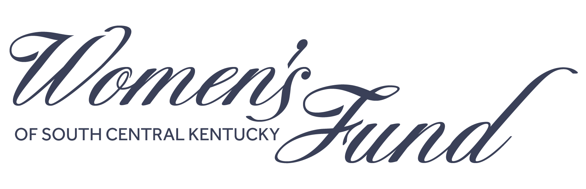

ANNUAL SPONSORSHIP FORM

COMPANY NAME COMPANY CONTACT TITLE EMAIL PHONE MAILING ADDRESS CITY STATE ZIP

Sponsorship Level:
Diamond $1,000

Pearl $500

In-Kind $250+ in value

Media Sponsor

PAYMENT [ALL DONATIONS ARE TAX DEDUCTIBLE AS ALLOWED BY LAW]

Enclosed is a check made payable to Community Foundation Women’s Fund.
Pay on-line
Please send me an invoice.
RETURN FORM + PAYMENT TO:
Community Foundation of SCKY / Women’s Fund
P.O. Box 737 Bowling Green, KY 42102

QUESTIONS: 270-904-2079 or jenniferw@cfsky.org

